Video Streaming Website

Computer Science 319

2/19/23

Jake Egler and Zachary Kreutner

Table of Contents

1. Project Introduction
2. Project Objectives
3. Possible Project Objectives
4. Work Strategy

### Project Introduction

YouTube is the primary streaming platform that people are drawn to when it comes to sharing or watching videos that people have made. While there are similar video-sharing sites that are relatively popular like TikTok or any other form of social media, no other site compares to the medium of video-sharing that is YouTube. This dominance makes it feel like YouTube has a monopoly on the video-sharing front, and this is the issue that we seek to rectify. We aim to create a website that is able to compete with YouTube as a video-streaming service, whether the content be long-form or short-form.

### Project Objectives

* Have a main page with a selection of videos available 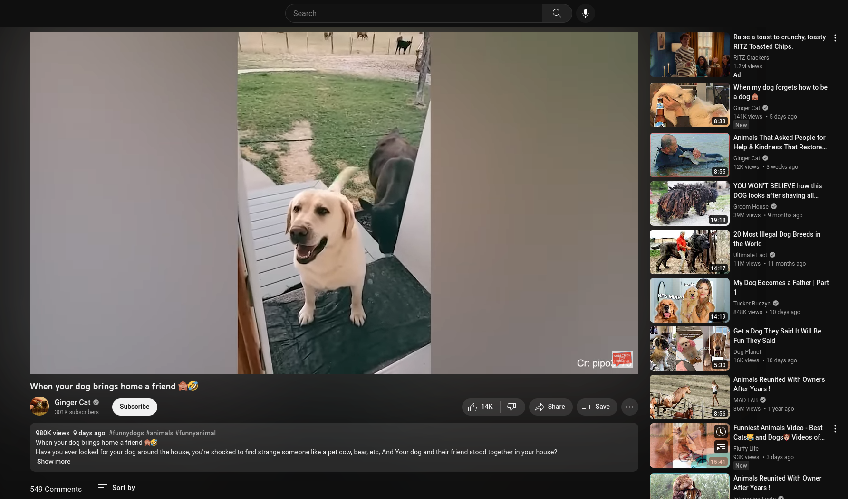
* Clicking on a video leads to a new page that plays the video
* The video player page will also display the metadata of the video (title, creator, date made, and a description)
* The video player page will have recommended videos to select from below the video player
* People can upload their own videos
* Including a way for users to easily search for videos
* Make efficient use of a database for backend data storage

### Possible Project Objectives

* The ability for users to upload their own videos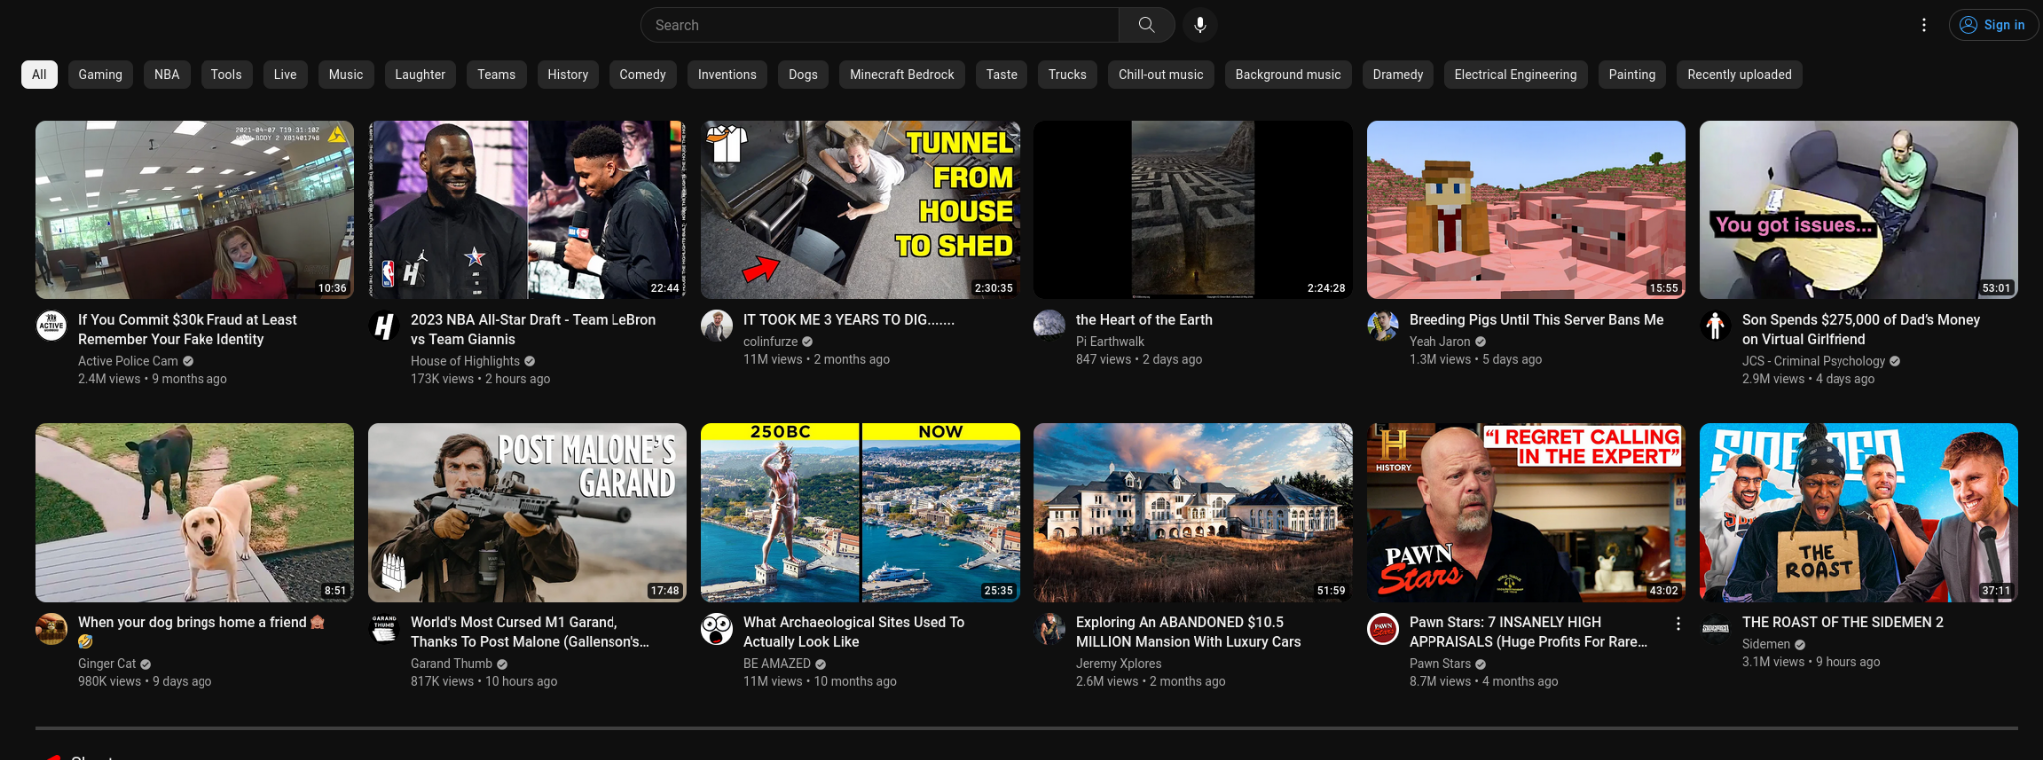

### Work Strategy

We plan on using discord for communication and Github for collaboration. The github repository will be split between 2 folders, one for front end and one for backend. Jake will work on the backend and Zachary will work on the front end. Jake has experience with SQL based databases so we will use a MySQL server for the backend database. We plan to meet up in-person at the ISU Library on Tuesday, Wednesday, and Friday at 6pm. In case we don’t make as much progress as we hope to, we can meet up in-person on Thursday at the same place and time and on Saturday over Discord at 2pm.